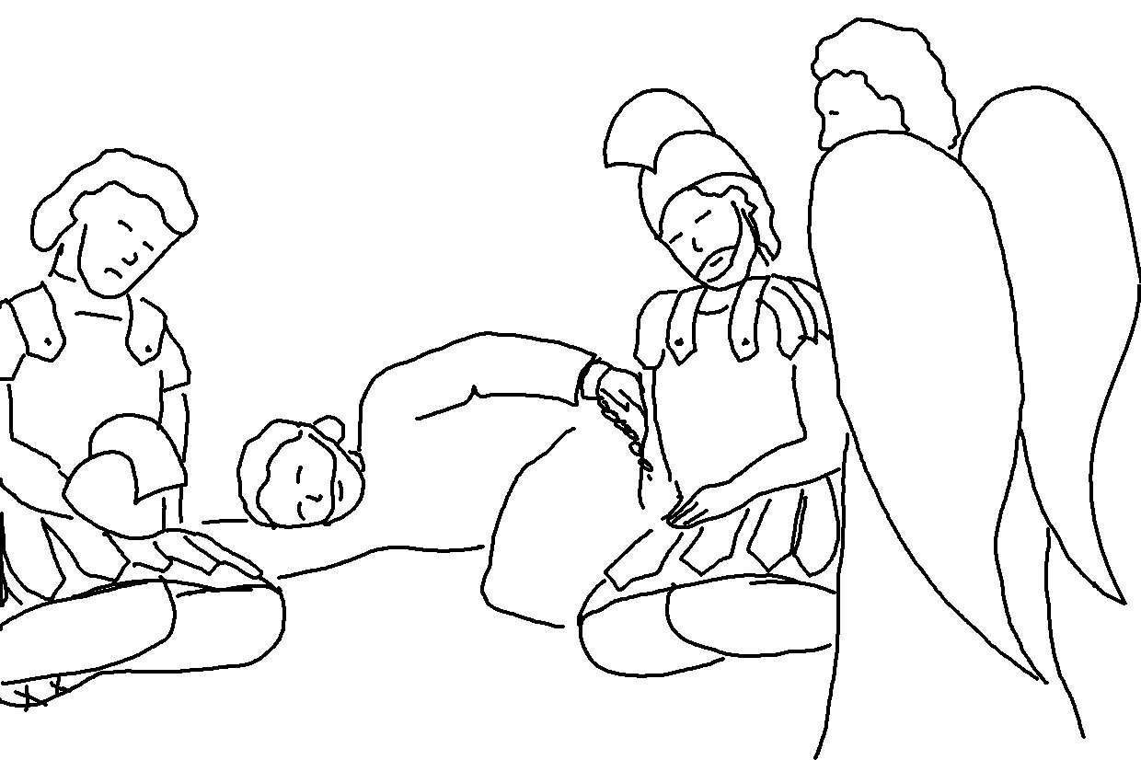
Keep on asking, and you will receive what you ask for. Matthew 7:7_{NLT}

